**AWS Federated Authentication**

* Once the IAM Federated Access is configured the authentication steps are 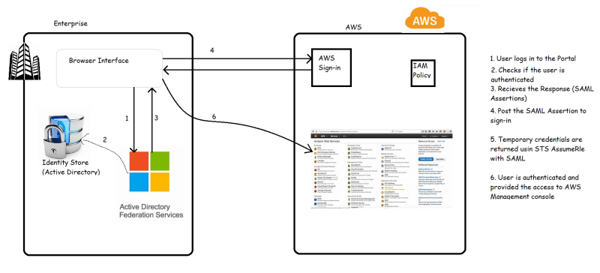
* For the Above steps to work, we need to configure Identity provider in IAM 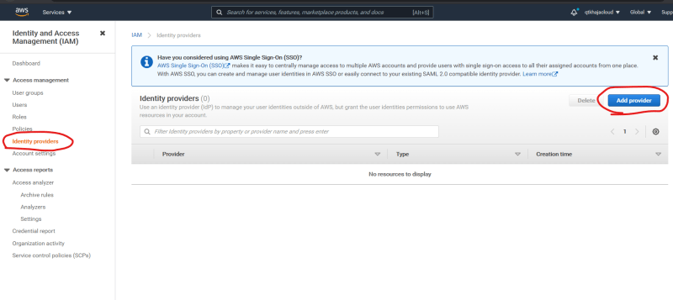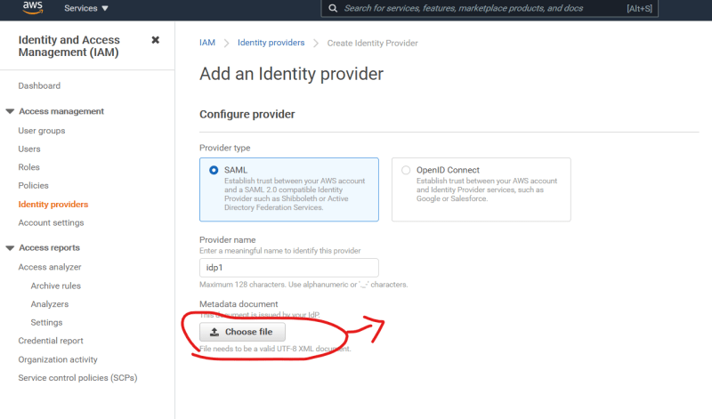
* THe FederationMetdata can be downloaded from your ADFS server by accessing (https://<yourADFSserver>/FederationMetadata/2007-06/FederationMetadata.xml). Sample federation <https://gist.githubusercontent.com/creativeprogramming/363aa9b0191a5c63dc6b/raw/46e68494bc609ec3d678c9aa8617bcf056389020/gistfile1.txt>
* Create a role with SAML federation & give admin access
* Now Create ADFS
  + Relying party Trust
* <https://aws.amazon.com/blogs/security/aws-federated-authentication-with-active-directory-federation-services-ad-fs/>